Introduction to Babysitting Course

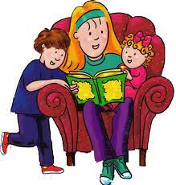

Babysitters have the responsibility of caring for children and making important decisions while they are in charge to keep not only the child safe but themselves as well. Parents entrust their child with the babysitter, therefore, it is crucial he or she knows the basics of child care. In this Introduction to Babysitting Course, participants will learn interviewing tips, communication skills, ages and stages of young babies and toddlers, safety and first aid tips, and feeding and caring for children, including diaper changing.

In addition, babysitters will learn steps he or she can take to decrease the spread of COVID-19 virus as suggested by the Centers for Disease Control and Prevention. Such precautions include taking their temperature, using hand sanitizer, and washing hands regularly. Participants will also learn symptoms to look for.

The instructor has taught Kindergarten and 2nd grade
and is currently a 1st grade teacher.
She holds three teacher certifications including Early Childhood,
General Education and Special Education and a Master’s Degree in Literacy

